Open Google.com in browser
Search for oracle live sql
Click and open the highlighted link
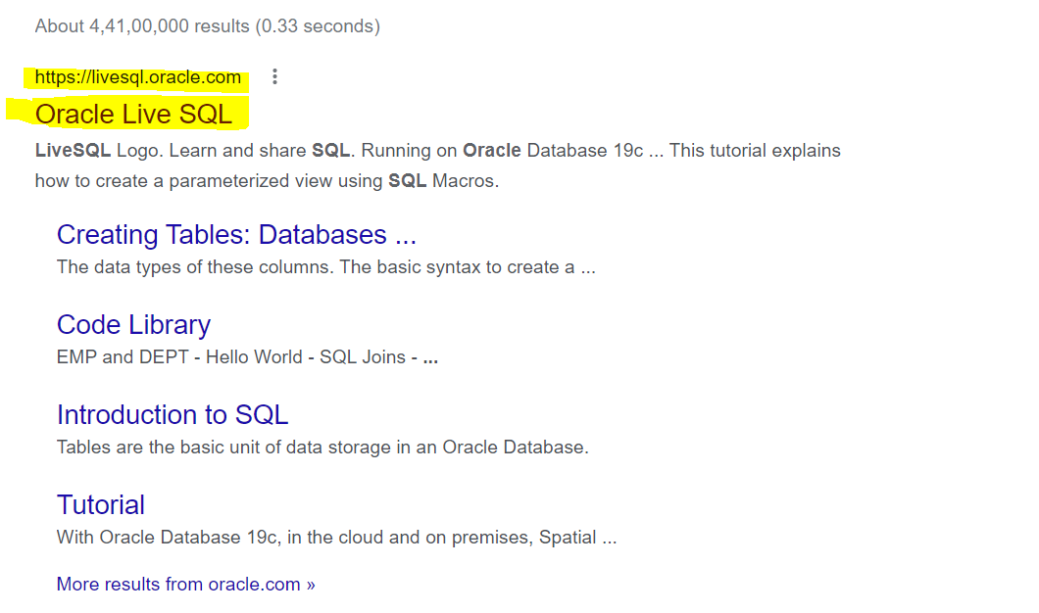

Click on Start Coding Now
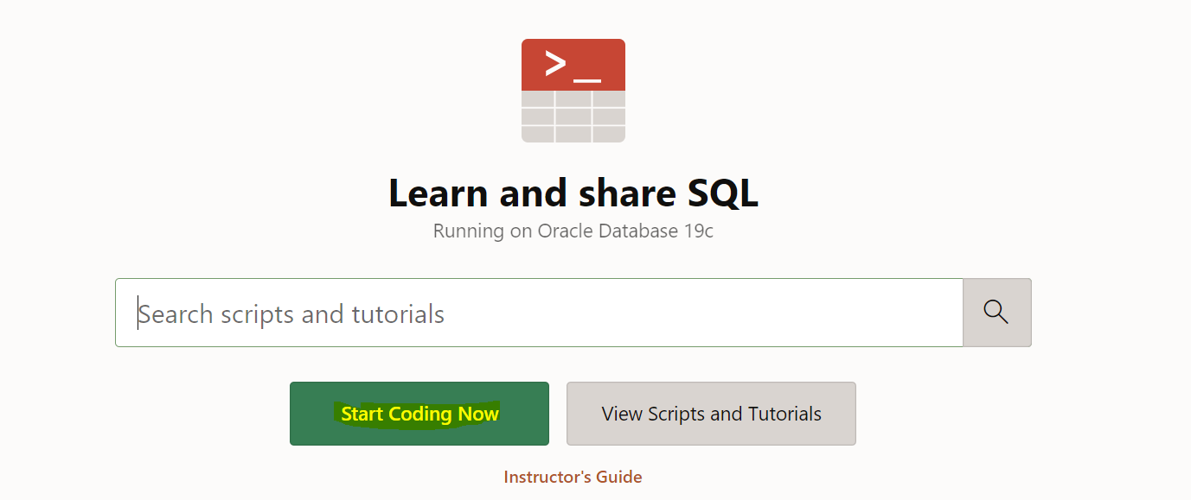
Enter the Username and password
If you do not have oracle account then create a new account (Click on Create Account)
And Login

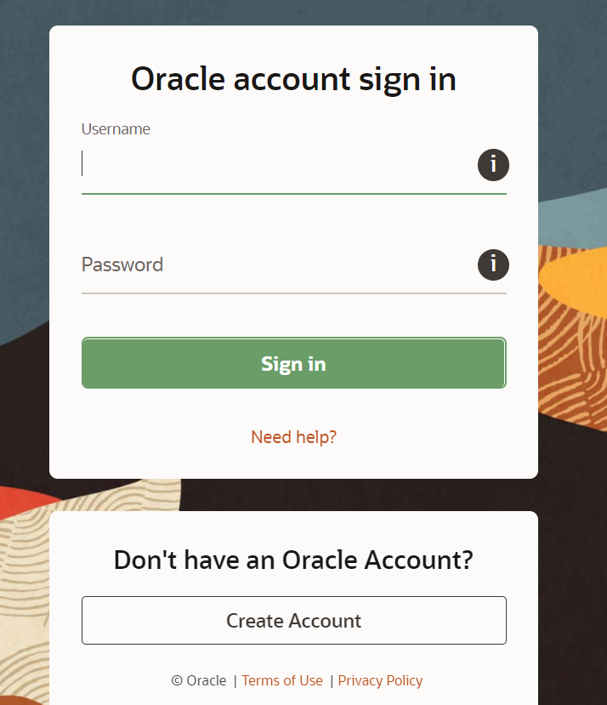

Under SQL Worksheet you can start your practice

